EXP -17 FUNCTIONS
PROBLEM 1
SQL QUERY
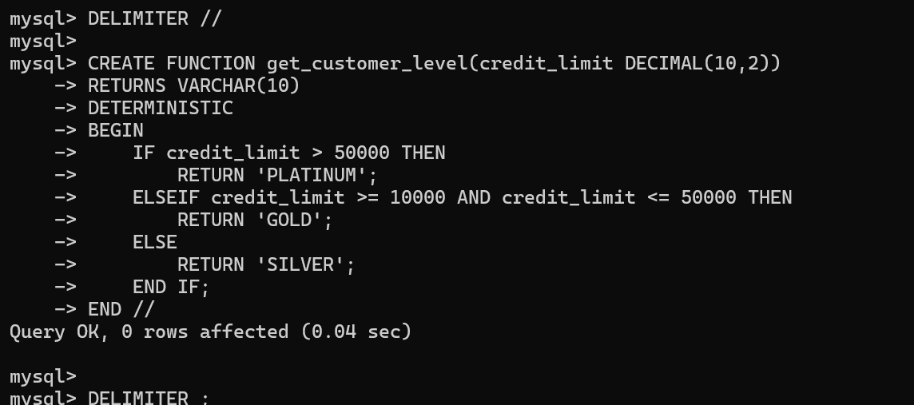
OUTPUT
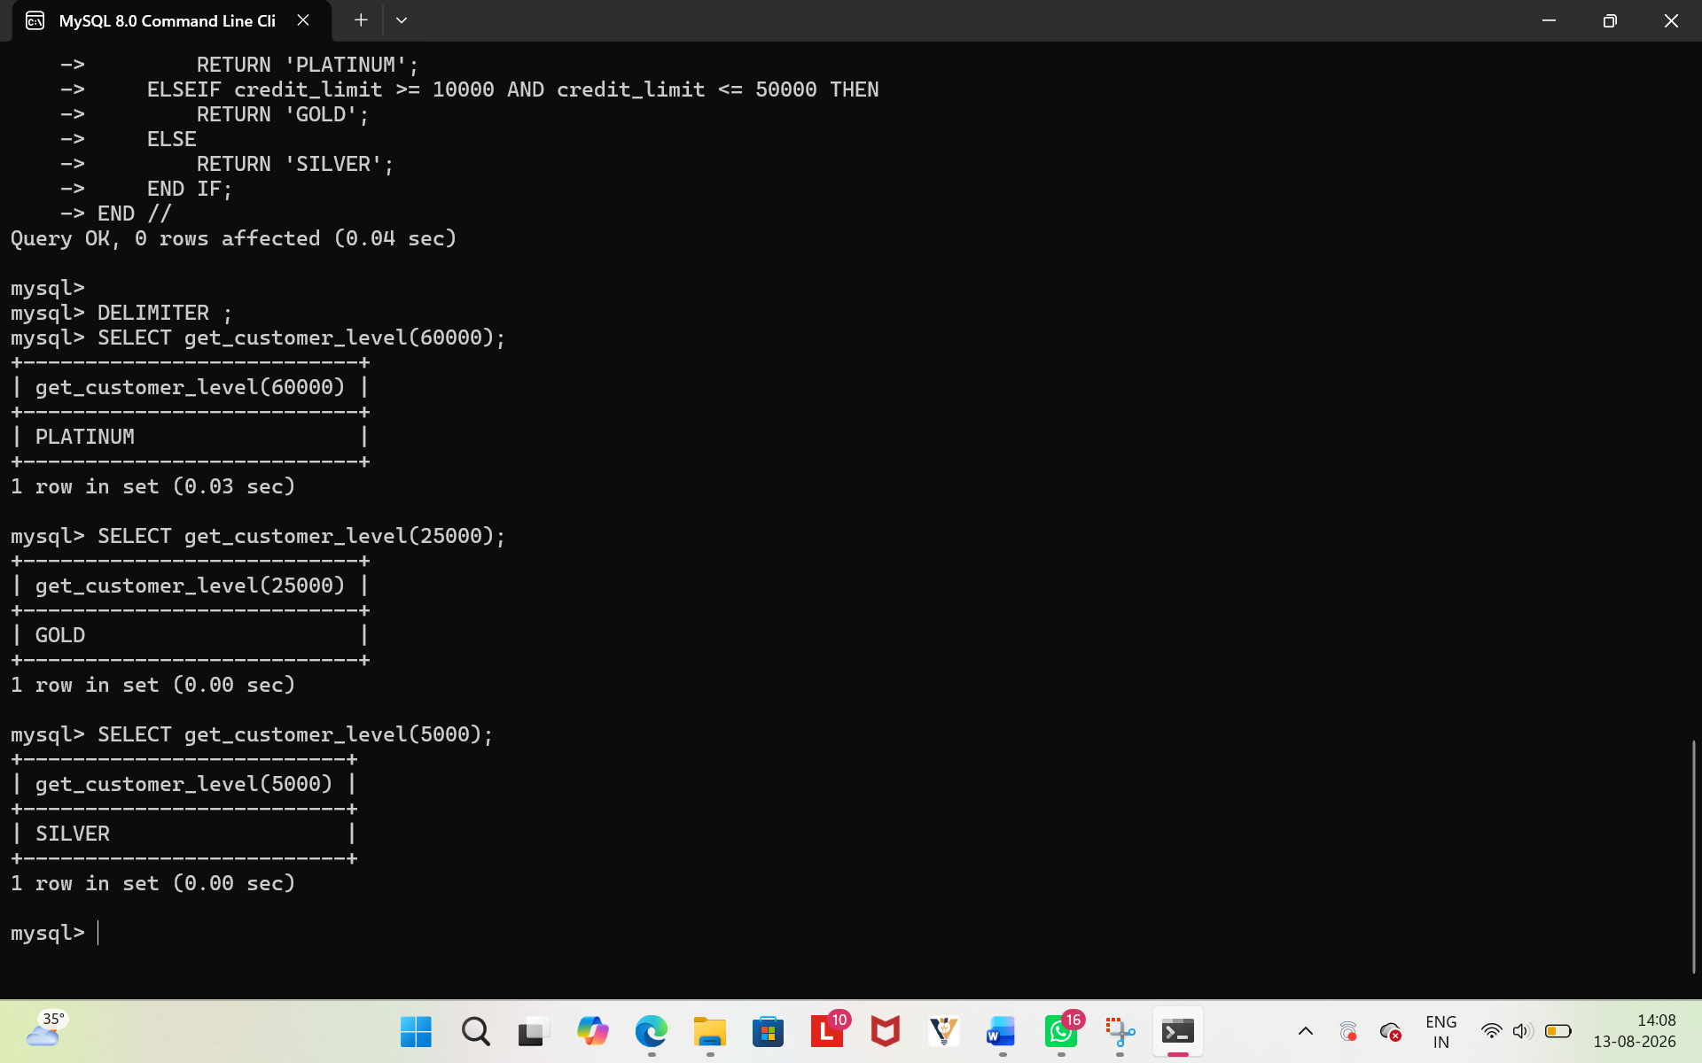

PROBLEM 2
